**Resultados del análisis de tiempos**

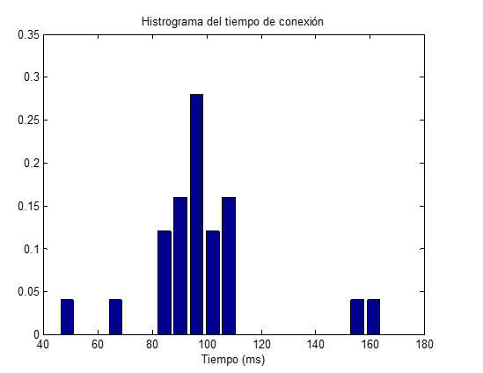

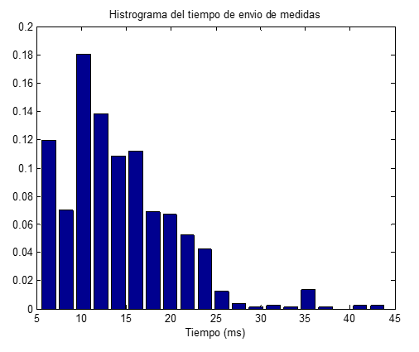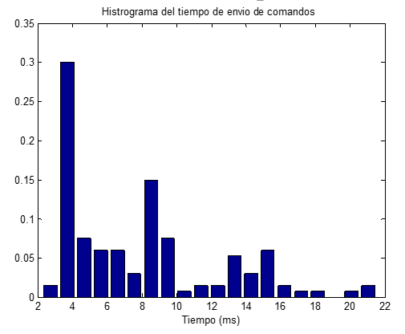

|  |  |  |  |  |  |  |
| --- | --- | --- | --- | --- | --- | --- |
| Tiempos  Evaluados | Media | Mediana | Perc. 80 | Perc. 90 | Perc. 95 | Perc. 99 |
| Conexión | 98.18 | 97.15 | 105.37 | 107.59 | 157.78 | 164.42 |
| Comandos | 7.87ms | 6,99ms | 12,53ms | 14,92ms | 15,98ms | 20,99ms |
| Medidas | 14.26ms | 12.93ms | 19.04ms | 22.1ms | 23.98ms | 35.65ms |